Successful social and ecological commitment:
millions donated to charity and a significant reduction in CO₂

Texaid Textilverwertungs-AG has brought its last financial year to a successful close. The money donated to charity and significant reduction in CO₂ are of particular note. Texaid generated more than 7 million francs from the sale of old clothing. It then donated this sum to various charities for social projects. Its commitment to an environmentally friendly corporate culture continued its positive development. Texaid reduced its CO₂ emissions significantly in relation to the base measurement year.

Texaid and its subsidiary Contex collected a huge quantity of old clothing throughout Switzerland once again last year. The population handed in over 36,000 tonnes of used clothing, shoes and household textiles via containers and by means of street and in-store collections. Texaid ensures that the textiles it collects are used in an environmentally friendly way. Whether they are worn again or made into cleaning cloths and insulation materials – old clothes are given a new life in the textile loop. This preserves valuable resources and considerably reduces environmental damage. Around 180 million Environmental Impact Points (EIP) were saved by Texaid as a result of collecting, sorting and recycling old textiles in 2016 (calculated on the basis of the average savings from the 2012 ecological assessment by Carbotech AG). This represents a saving equivalent to 540 million kilometres travelled by car, for example.

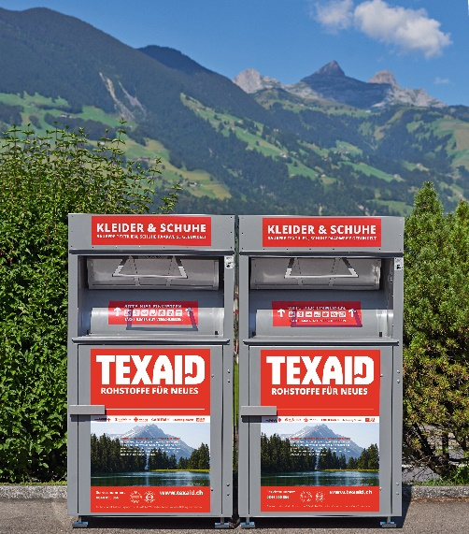
Over 7 million francs for social projects
In 2016 Texaid raised 7.2 million francs for charity thanks to the sale of textiles. Approximately 2.2 million francs were paid to the participating aid organisations. These include the Swiss Red Cross, Winterhilfe Schweiz, Solidar Suisse, Caritas Schweiz, Kolping Schweiz and the Hilfswerk der Evangelischen Kirchen Schweiz. A further 5 million francs were given to a number of Samaritan associations and other Charity organisations. This money is put towards various social and sustainable projects regionally, nationally and even internationally. These include an integration project for refugees in Switzerland, for example. More information on this and other Projects can be found on the Texaid website.

Over 6,000 Texaid containers are ready to receive
old clothing donations throughout Switzerland.

A 22-percent reduction in greenhouse gases
Texaid is constantly expanding its sustainability strategy and reducing its consumption of resources. It has set itself the goal of reducing the CO₂emissions caused by its own activities. Following various measures taken for the purpose of Swiss climate certification, 22 percent of CO₂ per tonne of old clothing collected was saved last year (in comparison with the base measurement year 2013). «The significant reduction in greenhouse gases we have achieved encourages us to forge ahead with our commitment to an environmentally friendly corporate culture and to define further measures to be taken in this area», sums um Martin Böschen, CEO of the Texaid Group.

Measures successfully implemented
To empty its containers, Texaid uses its own computer-aided logistics system which allows each individual container to be emptied at specific intervals. The map data used has recently been updated to ensure optimal route planning. The decision to introduce collection bags containing a proportion of recycling granules also contributed to the reduction in greenhouse gases. Whenever possible, employees also try to avoid going on long business trips, holding video conferences instead. A new Partnership with Swiss Post for street collections has been in operation since the beginning of 2017. As mail carriers combine the collection of clothing bags from private letter boxes with the delivery of letters, there are no empty journeys. The CO₂ savings achieved as a result will be seen in next year's evaluation.

Texaid was founded in 1978 as a charity-based private partnership by six Swiss aid organisations (Swiss Red Cross, Winterhilfe, Solidar, Caritas, Kolping and HEKS), along with an entrepreneur. With its headquarters in the Canton of Uri and branches in Germany, Austria, Bulgaria, Hungary and Morocco, the company is one of Europe’s leading textile recycling service providers. Texaid has an ISO-certified quality and environment management system in Switzerland (ISO 9001 & ISO 14001) and has been awarded the ‘carbon dioxide neutral’ label by Swiss Climate AG. Texaid employs around 140 members of staff in Switzerland.

Additional information:
Texaid press office
Telephone: 041 874 54 16
E-mail: pressestelle@texaid.ch
Website: www.texaid.ch

Photo material:
You can find relevant images on our website, under Downloads.
Caption: Over 6,000 Texaid containers are ready to receive old clothing donations throughout Switzerland.

